WEEK 06 -DECISION MAKING AND LOOPING -FOR

CODING

Reg no :241801289

Name :Tamilselvan.k

Q1

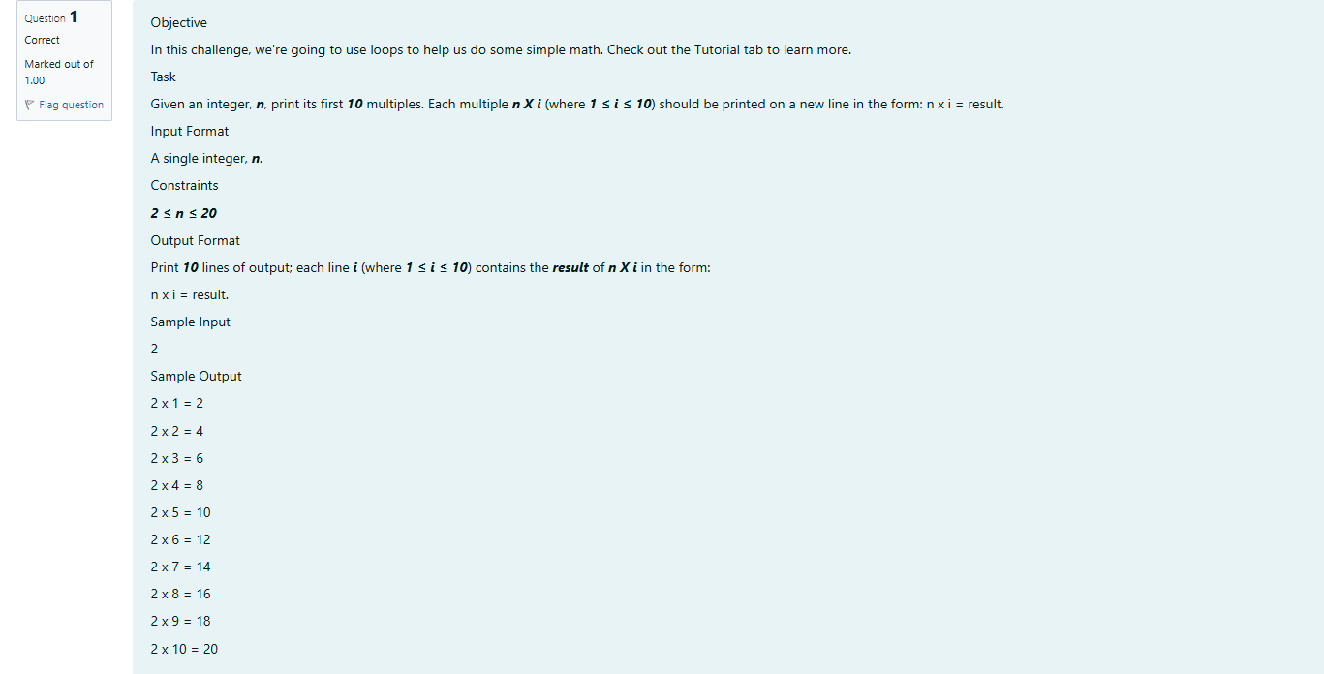

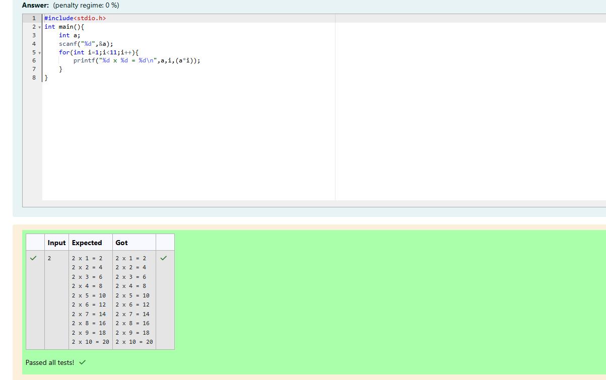

CODING

Reg no :241801289

Name :Tamilselvan.k

Q2

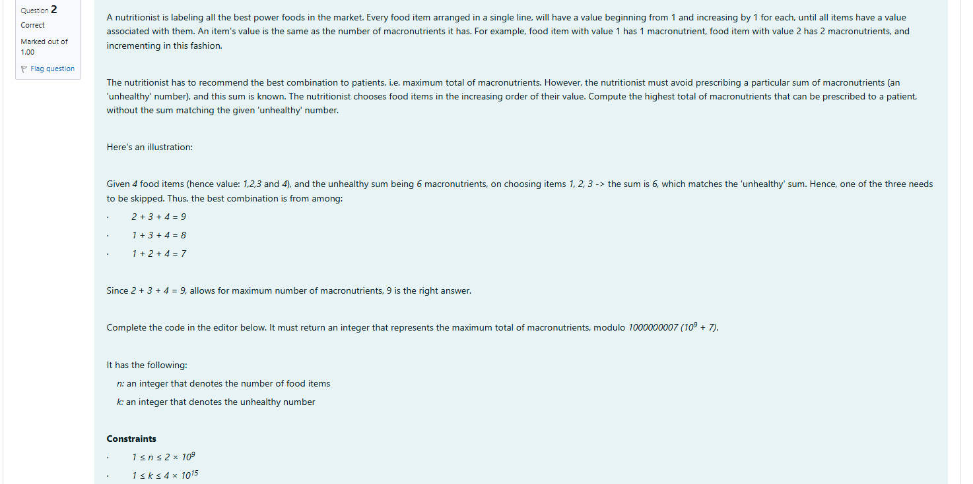

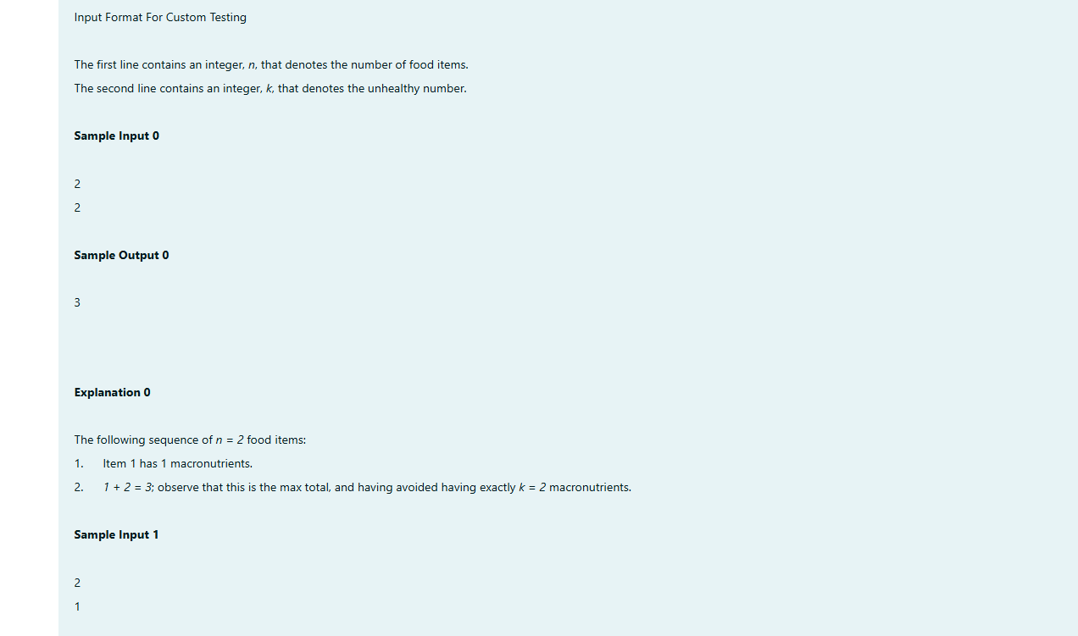

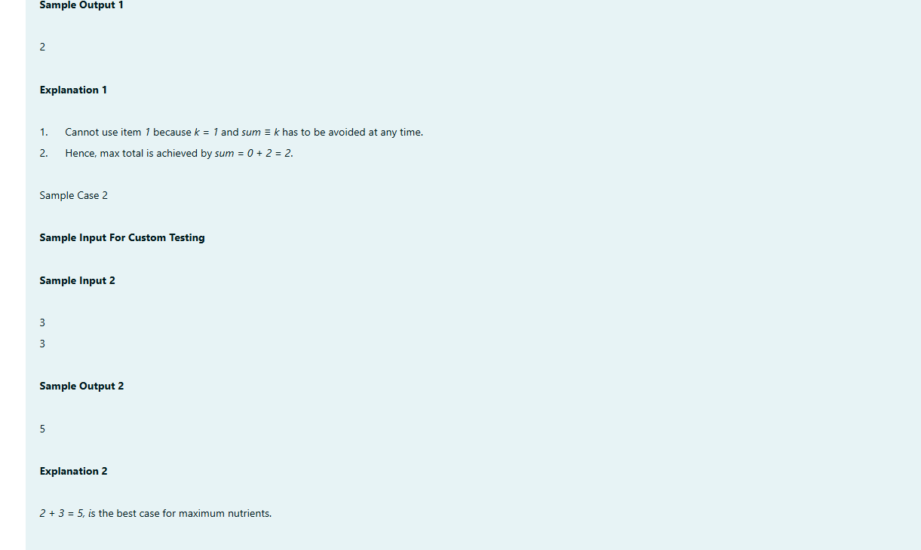

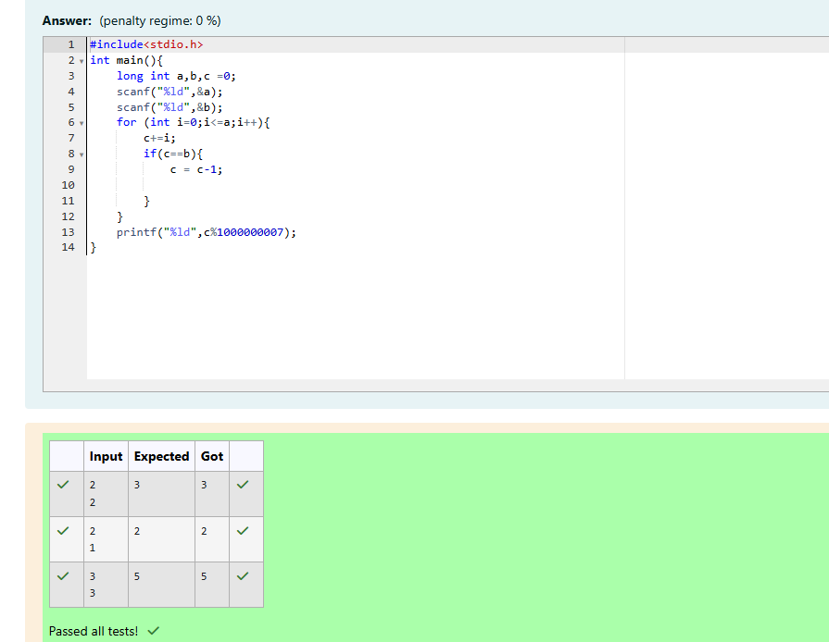

CODING

Reg no :241801289

Name :Tamilselvan.k

Q3

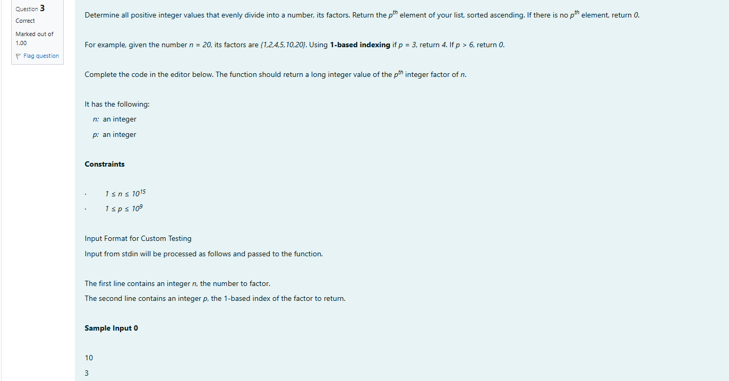

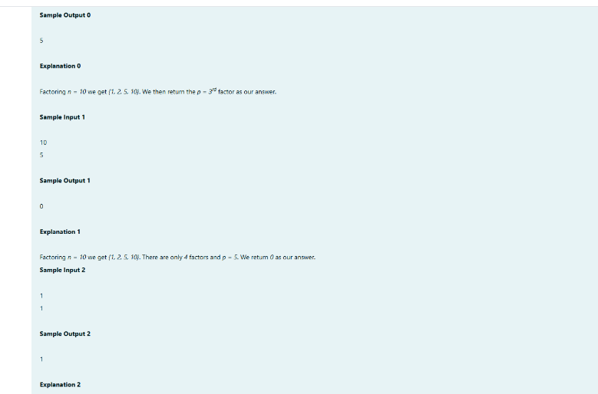

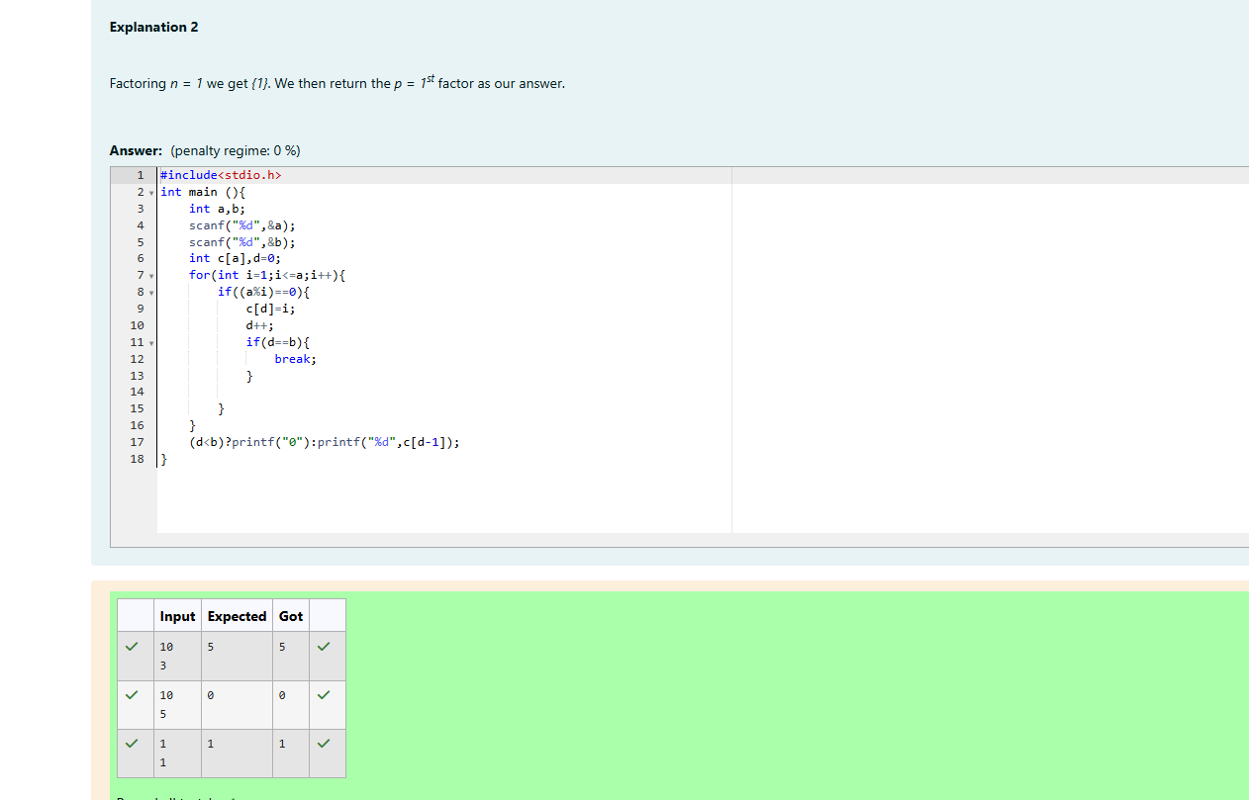

WEEK-06-ONE-DIMENSIONAL ARRAYS

WEEK-06-01-PARACTICE SESSION-CODING

Reg no:24180189

Name:Tamilselvan.k

Q1

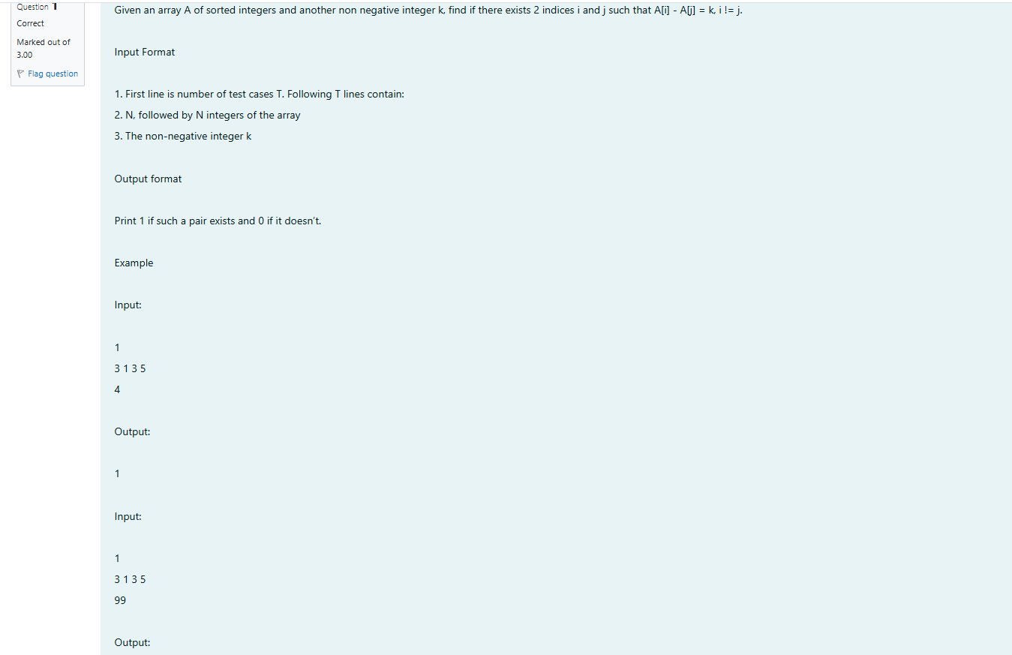

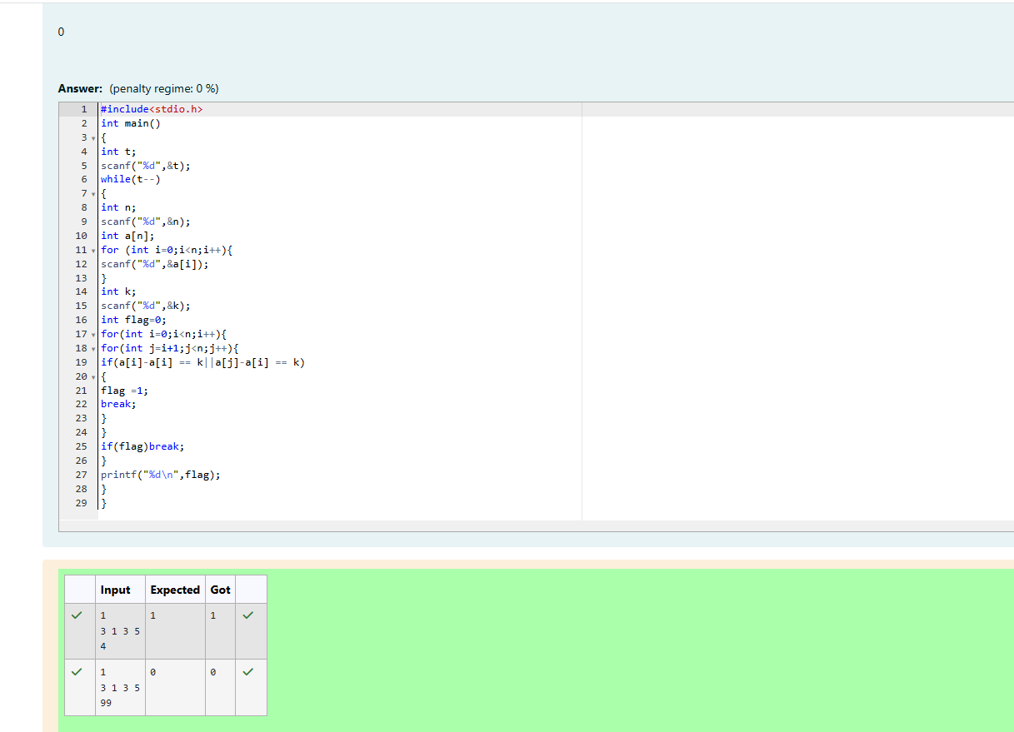

WEEK-06-01-PARACTICE SESSION-CODING

Reg no:24180189

Name:Tamilselvan.k

Q2

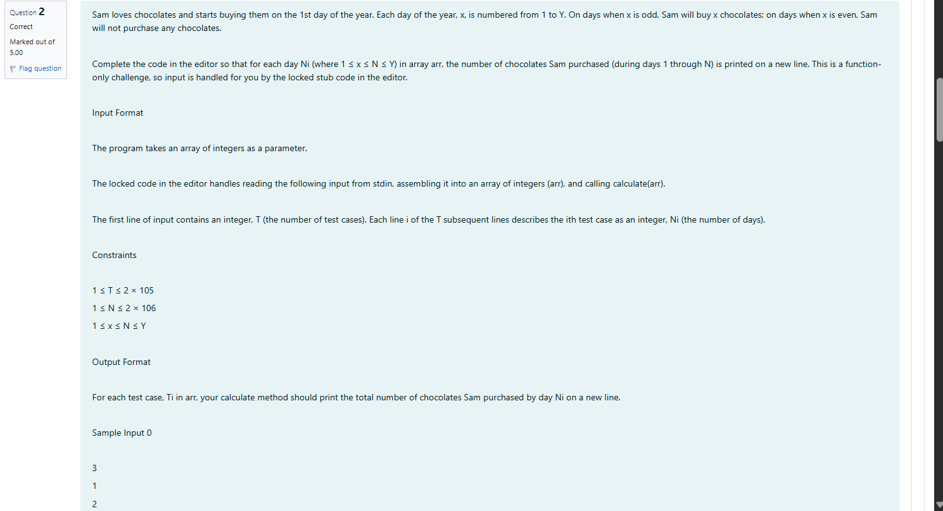

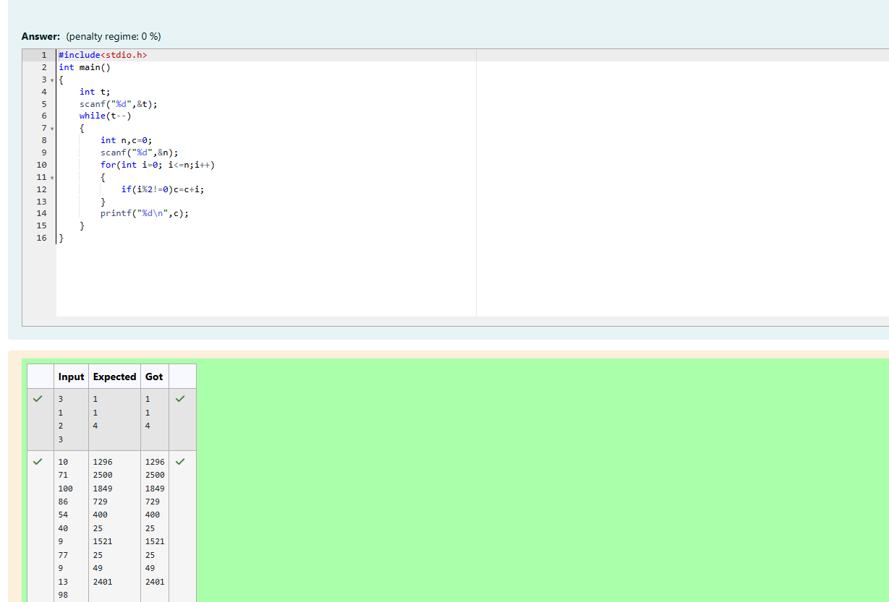

WEEK-06-01-PARACTICE SESSION-CODING

Reg no:24180189

Name:Tamilselvan.k

Q3

